SCHOOL

Trial WACE Examination, 2010

Question/Answer Booklet

MATHEMATICS:
SOLUTIONS

SPECIALIST

3A/3B

Section Two:

Calculator-assumed

Student Number: In figures

In words

Your name

Time allowed for this section
Reading time before commencing work: 10 minutes
Working time for paper: 100 minutes

Material required/recommended for this section

To be provided by the supervisor
This Question/Answer booklet
Formula sheet (retained from Section One)

To be provided by the candidate
Standard items: pens, pencils, pencil sharpener, eraser, correction fluid, ruler, highlighters

Special items: drawing instruments, templates, notes on two unfolded sheets of A4 paper, and up to three calculators satisfying the conditions set by the Curriculum Council for this course.

Important note to candidates

No other items may be used in this section of the examination. It is your responsibility to ensure that you do not have any unauthorised notes or other items of a non-personal nature in the examination room. If you have any unauthorised material with you, hand it to the supervisor before reading any further.

Structure of this paper

Section | Number of questions available | Number of questions to be answered | Working time (minutes) | Marks available
Section One:  Calculator-free | 7 | 7 | 50 | 40
Section Two:  Calculator-assumed | 11 | 11 | 100 | 80
 |  |  |  | 120

Instructions to candidates

- The rules for the conduct of Western Australian external examinations are detailed in the Year 12 Information Handbook 2010. Sitting this examination implies that you agree to abide by these rules.

- Write your answers in the spaces provided in this Question/Answer Booklet. Spare pages are included at the end of this booklet. They can be used for planning your responses and/or as additional space if required to continue an answer.
- Planning: If you use the spare pages for planning, indicate this clearly at the top of the page.
- Continuing an answer: If you need to use the space to continue an answer, indicate in the original answer space where the answer is continued, i.e. give the page number. Fill in the number of the question(s) that you are continuing to answer at the top of the page.

- Show all your working clearly. Your working should be in sufficient detail to allow your answers to be checked readily and for marks to be awarded for reasoning. Incorrect answers given without supporting reasoning cannot be allocated any marks. For any question or part question worth more than two marks, valid working or justification is required to receive full marks. If you repeat an answer to any question, ensure that you cancel the answer you do not wish to have marked.

- It is recommended that you do not use pencil except in diagrams.

Section Two: Calculator-assumed (80 Marks)
This section has eleven (11) questions. Answer all questions. Write your answers in the space provided.

Working time for this section is 100 minutes.

Question 8 (6 marks)
The circumference of a circle of radius 25cm passes through the centre of a circle of radius 15cm. Find the area of intersection of the two circles.
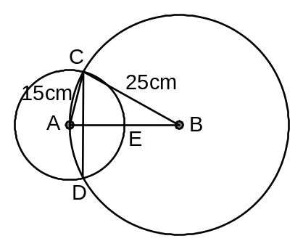

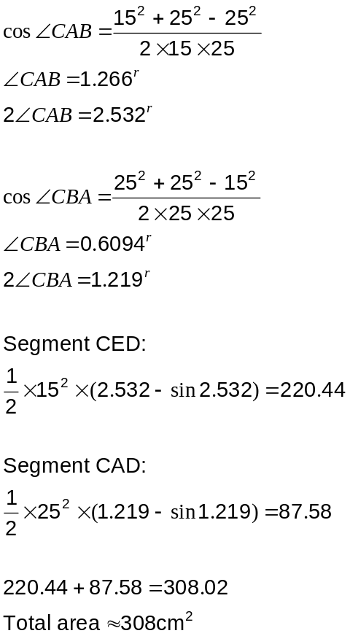

Question 9 (7 marks)
(a) For each of the following, state whether or not the function is continuous over the given domain. If not, explain why and state where it is not continuous. (3 marks)

(i) 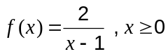.

No.

When 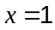  is undefined.

(ii) 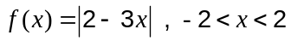.
Yes.

(b) For each of the following, state whether or not the function is differentiable over the given domain. If not, explain why and state where it is not differentiable. (4 marks)

(i) 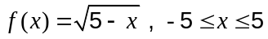.

No.

At 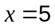, the gradient of to the right of 5 does not exist.

(ii) 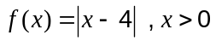.

No.

At 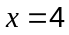, the gradient of just to the left of 4 does not equal the gradient of just to the right of 4.

Question 10 (8 marks)
(a) The two distinct solutions of the quadratic equation 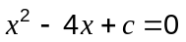 are both complex. Determine all possible values of . (3 marks)

Discriminant must be less than 0:

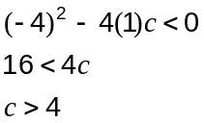

(b) If 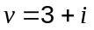 and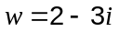, find the complex number such that 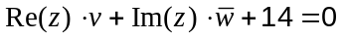.
(5 marks)
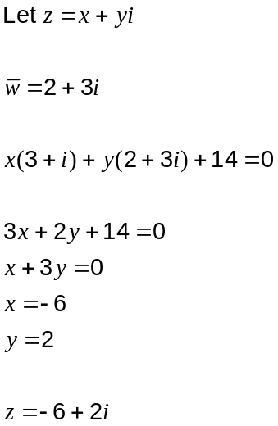
Question 11 (7 marks)
At midnight a coastal freighter has position vector 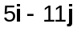 km and is steaming with a constant velocity vector of 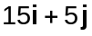 km/h. At this time, the distance between it and a dangerous reef located at 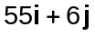 is decreasing. Let t be the time in hours after midnight.

(a) Find a vector for the position of the freighter relative to the reef at any time t. (2 marks)
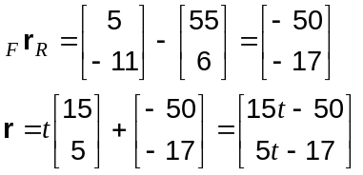

(b) When the distance of the freighter from the reef is a minimum, what can be said about the scalar product of the velocity vector of the freighter and your answer to (a)? (1 mark)
Scalar product will be zero, as closest when these two vectors are perpendicular.

(c) Use your answers to (a) and (b) to determine the minimum distance the freighter will come to the reef. (4 marks)
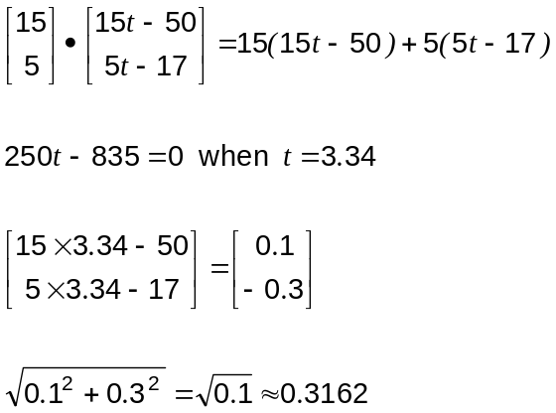

Freighter comes within 320m of reef.

Question 12 (8 marks)
The initial area of a lupin crop, , in square metres, infested by cowpea aphids was 230m². One week later the area infested had increased to 270m².

(a) Assuming that the area infested is increasing exponentially, write a formula for in terms of , the number of days since observations began. (3 marks)
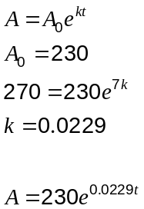

(b) Sketch the graph of the area infected against time for the first 7 weeks on the axes below.
(3 marks)
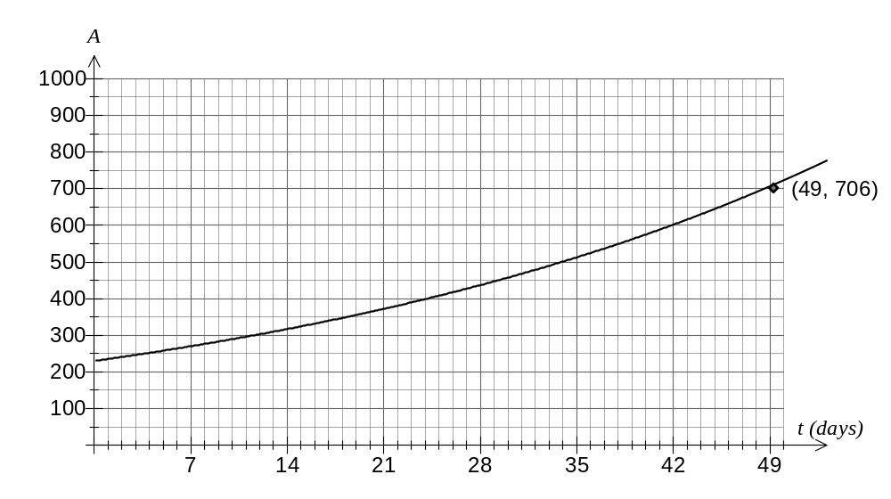

(c) If no measures were taken to control the spread of cowpea aphids, after how many days will more than 1400m² of the crop be infested? (2 marks)
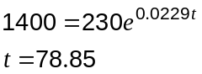

After 79 days.

Question 13 (5 marks)
The three points A, B and C have position vectors 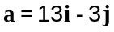, 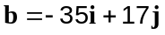 and 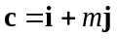 respectively. The point C divides AB internally in the ratio 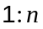. Find the values of and .

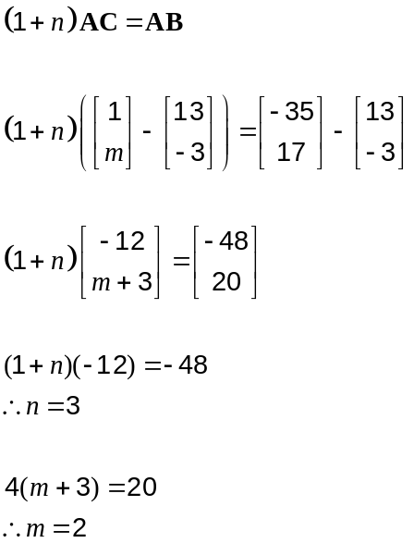

Question 14 (8 marks)
A current of constant velocity 2 km/h runs parallel to the sides of a straight section of a shipping canal. The skipper of a small boat motors at a speed of 8 km/h on a bearing of 237º in the canal. Due to the current, the boat appears to be moving directly towards a pontoon on the canal edge, which is on a bearing of 245º from the boat.

If the speed of the boat over the canal floor is less than its actual speed through the water determine

(a) the bearing on which the current is flowing. (5 marks)
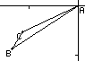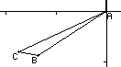

AB is boat relative to water, BC is water relative to earth, AC is boat relative to earth.

2 solutions to triangle with AB=8, BC=2 and BAC=245-237=8º.

Must choose LH diagram (C obtuse) as given that |AC|<|AB|.

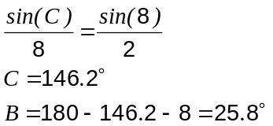

Bearing is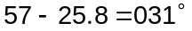 to nearest degree.

(b) the time the boat will take to reach the pontoon, to the nearest minute, if the pontoon is 650m away. (3 marks)
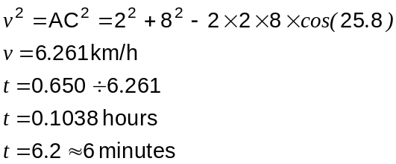

Question 15 (7 marks)
Two functions are given by 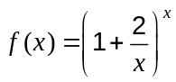 and 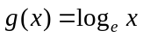.

(a) Complete the table below, rounding values to 4 decimal places where appropriate.
(3 marks)

 |  | 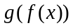
1 | 3 | 1.0986
10 | 6.1917 | 1.8232
100 | 7.2446 | 1.9803

(b) Determine the limiting value of as . (2 marks)
10000 | 7.3876 | 1.9998
1000000 | 7.3890 | 2.0000

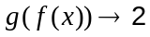

(c) A conjecture was made that 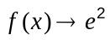 as . Explain how your answer from part (b) supports this conjecture. (2 marks)
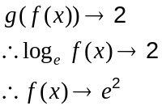

Question 16 (9 marks)
(a) A circle with centre C has equation 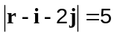.

(i) Show that the point A with position vector 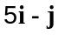 lies on the circle. (2 marks)
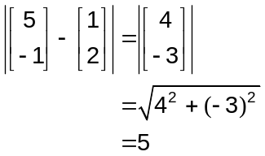

(ii) If AB is a diameter of the circle, determine the position vector of B. (2 marks)
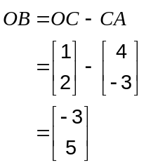

(iii) Determine the vector equation for the tangent to the circle at A. (2 marks)
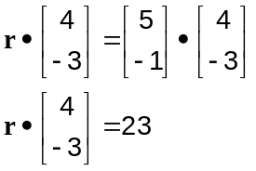

(b) Given that 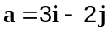, 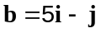 and 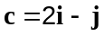, express in terms of and . (3 marks)
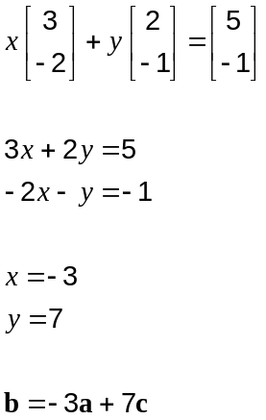

Question 17 (9 marks)
A function is given by 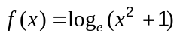.

(a) Show that has just one stationary point and find its location. (2 marks)
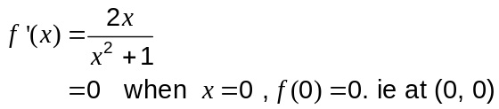

(b) Show that has two points of inflection and determine their coordinates in exact form.
(2 marks)
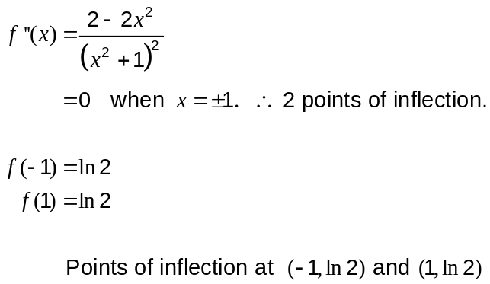

(c) Sketch the graph of on the axes below. (2 marks)
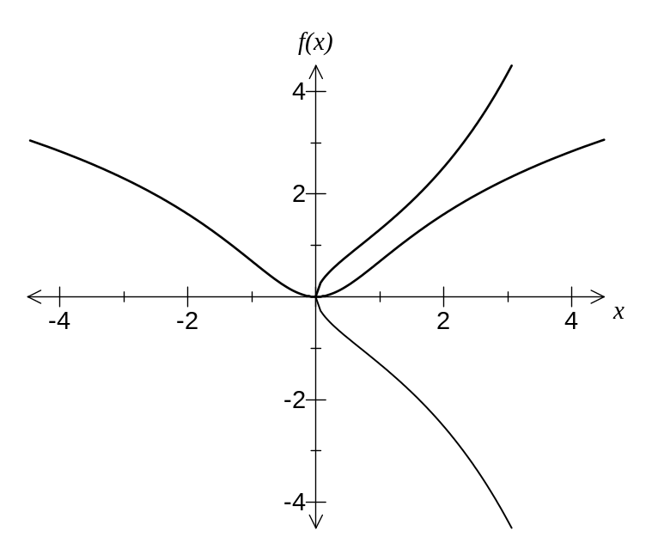
(d) On the same axes, sketch the graph of 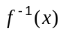. (2 marks)

(e) Explain whether or not is a function. (1 mark)
No. The graph shows it is a one-to-many mapping.
Question 18 (6 marks)
A body in equilibrium is acted on by three forces, as shown in the diagram (not to scale).
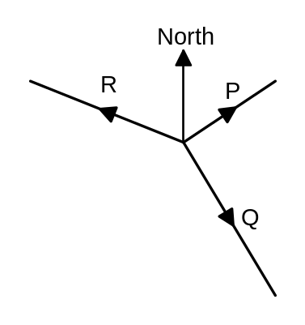
P is of magnitude 350N on a bearing of 060°, Q is of magnitude 600N on a bearing of , where 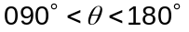, and R is of magnitude N on a bearing of 285°.

Determine and .

For equilibrium, P + Q + R = 0
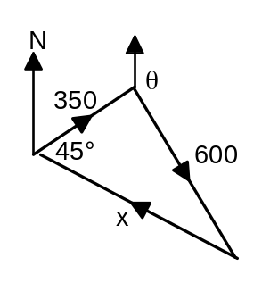
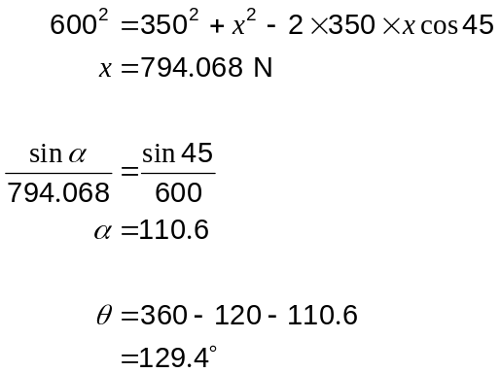

Additional working space

Question number(s):

Additional working space

Question number(s):

